|  |  |  |
| --- | --- | --- |
| GO Classes 2023 C Programming 1 | C Programming | Number Representation, Control Statements (if-else, switch-case, loops), Operators |

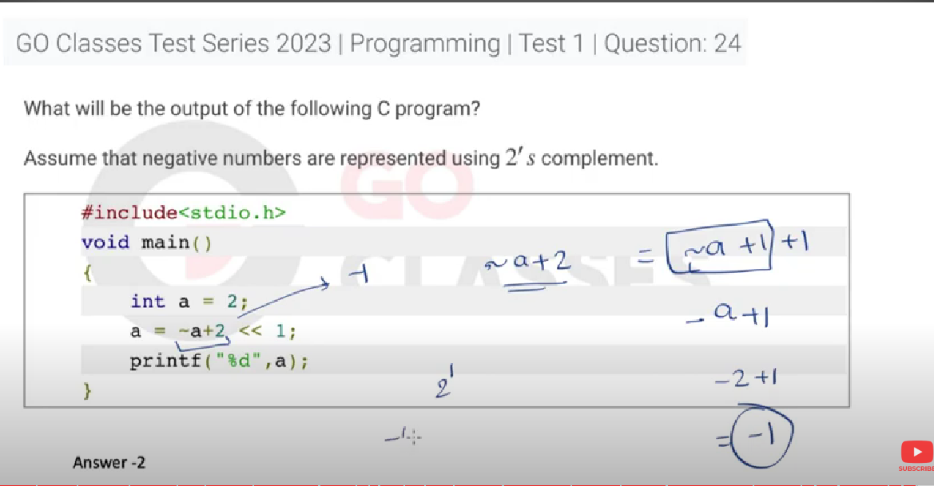

[Programming: GO Classes Test Series 2023 | Programming | Test 1 | Question: 25 (gateoverflow.in)](https://gateoverflow.in/374121/go-classes-test-series-2023-programming-test-1-question-25)

[Programming: GO Classes Test Series 2023 | Programming | Test 1 | Question: 21 (gateoverflow.in)](https://gateoverflow.in/374125/go-classes-test-series-2023-programming-test-1-question-21)

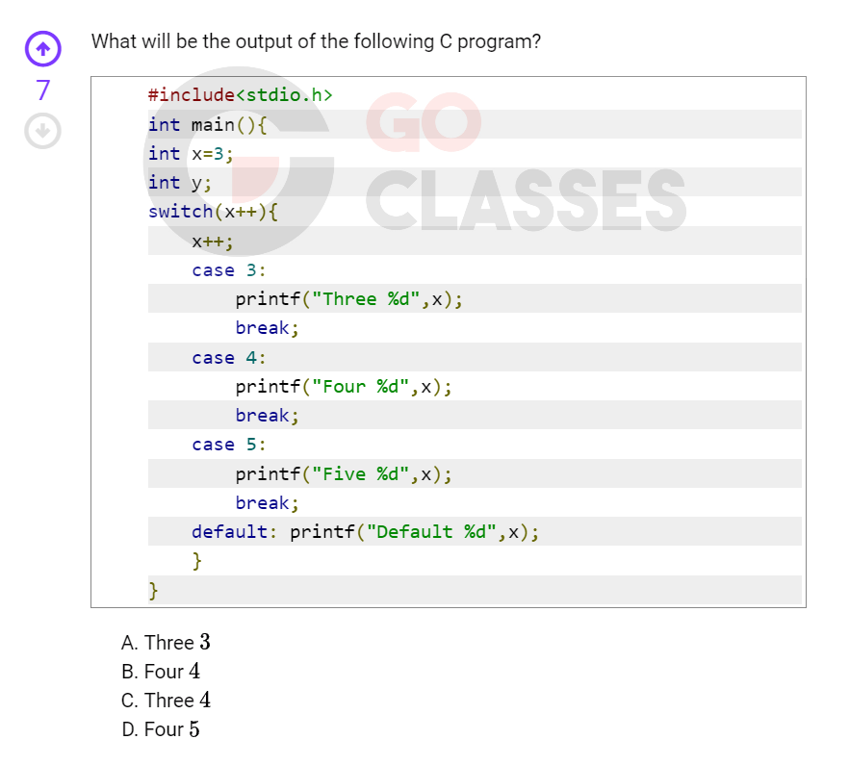

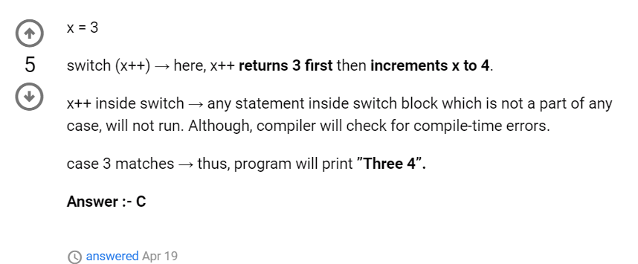

<https://gateoverflow.in/374047/switch-case-statement?show=387690#c387690>

[Programming: GO Classes Test Series 2023 | Programming | Test 1 | Question: 19 (gateoverflow.in)](https://gateoverflow.in/374127/go-classes-test-series-2023-programming-test-1-question-19)

<https://gateoverflow.in/374128/go-classes-test-series-2023-programming-test-1-question-18?show=387691#c387691>

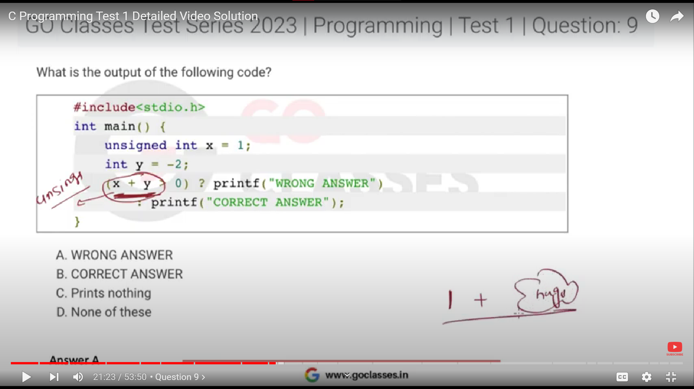

Unsigned +signed = signed + unsigned = CONVERTED ALL TO UNSIGNED

generally speaking let any negative integer  **-k  :**

When type casted to unsigned int it becomes :   **[Max Unsigned - (k-1)] or**

**Trick: suppose 8 bit signed to 8 bit unsigned :-**

Suppose,  
  
signed int i = -1, j = -5;  
  
unsigned int m = i, n = j;  
  
Where both takes 8 bits.  
  
The value stored in m is 255 and value stored in n is 251.  
  
Since, i=m=11111111 and j=n=11111011.

<https://gateoverflow.in/374136>

[Programming: GO Classes Test Series 2023 | Programming | Test 1 | Question: 6 (gateoverflow.in)](https://gateoverflow.in/374140/go-classes-test-series-2023-programming-test-1-question-6)